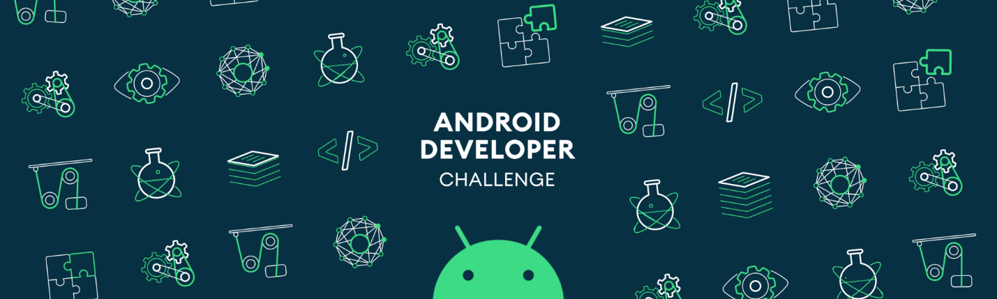

**Tell us what your idea is.**

*Around a few months ago, I had started to create the retailer platform that provides user to see sale or rent houses easily. This project contains 2 steps (website and Android mobile app). The website has been finalized with idea that the house owner or retailer can be logged in platform and adding their house through the dashboard. Now, I am developing Android application with AR technology that displaying info about the building user are looking at.*

*At this project, I will collect the user behaviour and selection through their mobile application. Then, I will implement ML model using Tensorflow for all collected data from my retailer app at server-side. I will create useful ML model that based on information such as user location, home properties (room of home, built year, price, availability of credit) and train the model by using Neural Networks. Then, I will suggest the newly added house based on their criteria even they will not make any selection at application. Just depends of user behaviors on mobile app will guide me to built ML model for this idea.*

**Tell us how you plan on bringing it to life.**

***The current status of the project***

*Currently, The website of the platform has been finalized with a few minor defects. But at mobile side, I have only been able to create the login and registration pages. The mobile app still didn’t redesign based on collecting data for ML models. Firstly, I will try to make some researches what is the major inputs for user to decide their dream house. Then, I will search some datasets from retail industry that will help house suggestion mechanism. Based on model and user behavior, the API of project will be renewed. You can reach the website platform on line by clicking* [*http://findhouze.com*](http://findhouze.com) *link. Also, you can have main of the project idea* [*http://findhouze.com/how-it-works*](http://findhouze.com/how-it-works)

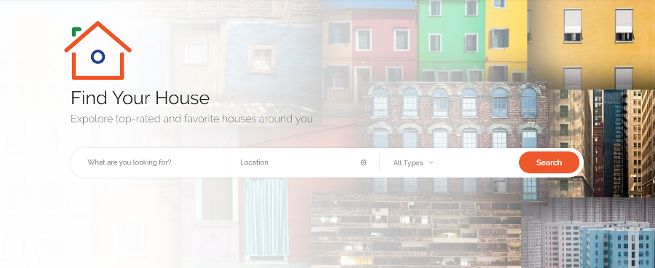

***To achieve the project goal, Google can help us by;***

* *Assigning experienced mentor for the retailer project*
* *Free API Token to train ML models through using Google APIs*
* *Helping us to reach a wide audience*
* *DataSet about retail platform (if possible)*

***Timeline;***

***December 2019***

* *Analysis of Google ML Solutions*
* *Research and Learning*

***January 2020***

* *Building model based on ML technique*
* *Collecting dataset manually to create algorithm*
* *Implementation of Google Tensorflow on server-side*

***February 2020***

* *Working with app designer to finalize the interface of mobile app*
* *Continue to develop Android app from remaining part*
* *Implementation of main functionality of mobile app*

***March 2020***

* *Trying to finalize developing Android app*
* *Building API system to save user behaviors from mobile app*
* *Training the dataset with created ML models*
* *Also training the dataset providen by Google (if possible)*

***April 2020***

* *Publish application at Google Play Store*
* *Working with real user experience and get the feedback about the suggestion*
* *Updating ML model based on user feedback*

**Tell us about you.**

Well, I am Mustafa Celik from Turkey. I’m currently working such as Senior Mobile & Web Developer at TAV Technologies. I've been in the aviation industry latest five years, primarily working in web and mobile development team. I’ve designed and developed core features for aviation Android application using Java. Also, I’ve developed smart TV and smart watch applications on Android device. Based on our company need, the kiosk application has been created too. Before that, I’ve worked with media channels, investors, engineers, and product management to deliver user-friendly and visually appealing mobile applications ensured that content met or exceeded business and client requirements 100% of the time for the Android platform on different projects.

I have created and tested around 20+ Android native applications. The best one was a music app for Android users (2.5M+ downloads to date). Also, have developed investor relation applications for two well-known companies at Turkey. I have own Android applications that was downloaded over 200K times at Google Play Store.

About my project, I’ve an experience about neural network project before graduating from univercity. The project was teaching multiplication table with computer by using neural network system. In current company, I am working on airline prediction models to inform passenger about airline-delay.

The retail sector has more businesses than any other industry with13.9% of the total according to trustworthiness reports. I want to focus on the real world problem and the the retail industry has several market gaps over the years.